

Training Manual

August 2013

Table of Contents
Physical Facilities 3
Paperwork 5
Vehicles 7
Chemicals 12
The Label 13
Service Procedures 14
Pest Control Treatments Residential 15
Daily Routine 19
Customer Relations 20
Sales Estimates 21
Collections 22
Training Protocol and Tests 23
Scheduling of Accounts 27
Daily Meetings and Daily Task Sheet for Managers. 32
Meetings, Checklists, Schedulers 35
Pre-treat Training and Timing 36
Field Supervisor Checklist 37
WDIR Reports 42
Forms 43
Mail Correspondence 49
Marketing 50

Physical Facilities

Parking Lot
A parking lot is furnished to park personal and company vehicles. Park your vehicle where it will not block parking lot access and park to allow for customer parking further away from the building.

Technician Room and Bath Rooms
A technician room and bathrooms are in each office. It is the responsibility of each technician to maintain all physical facilities clean and neat.

Technician Message and Office Boxes
Technician office boxes are in each office. It is the responsibility of each technician to pick up messages and memos on a regular basis.

Call Back Systems and Return Phone Calls
All calls are to be returned within 1 hour. If the calling party has not called you back within 4 hours, it is your responsibility to continue to call them at least twice a day or more often if the situation requires immediate contact. Do not be a, “I returned the call and have not heard back because they did not call me back.” Take the initiative and responsibility to make contact with a calling party.

Schedules
Service Schedules are to be picked up and completed on a daily basis. Schedules are to be picked up at the office each morning from the service technician’s respective supervisor. There is no reason that a schedule will not be completed. If an account cannot be serviced or completed for any reason the service technician is to immediately call their scheduler and supervisor. The technician is to then get another account to take the place of the account that could not be completed. There is no excuse for not calling a scheduler and supervisor if an account cannot be done. There is no excuse for turning in a daily report for the previous day with account skips when the scheduler and supervisor was not contacted as soon as you found out service could not be rendered. As soon as a technician finds out an account cannot be completed nor done they must call the office immediately.

Scheduling Book
In most cases, scheduling is handled by an office scheduling staff.

Gas Pump Location
Gas cards are furnished and gas should be purchased at approved gasoline providers and approved gasoline locations only.

Chemical Room Location and Hours
Chemical is to be procured each morning and given out by approved management. No one but approved individuals is to be in the chemical shed at any time. Used chemical containers are to be turned in and logged in by each technician’s respective supervisor.

Car Wash
Washing soap and washing materials are furnished at the office location. At no time is it acceptable for an Arrow truck to be dirty.

Paperwork

Daily Production Report
Daily production reports are to be turned in to your supervisor daily for the previous day’s work. Production reports are not to be held for more than one day without permission from your supervisor, and then only for a good reason such as you worked out of town the previous day and could not come into the office. Production totals, invoices with correct dollar amounts, chemical percentage’s, EPA no’s, graphs, gas purchase invoices, etc. should be turned in the next day with your daily production report.

Turning in Your Daily Production
Daily Production Reports are to be turned in daily.

Call Back Systems
In most cases, a radio or phone is furnished to service technicians. Service Technicians are to call their scheduler when they arrive at each service stop and when they leave each service stop. Service Technicians are to check for messages at least twice a day and return all messaged that day or leave a message for the caller. They then should attempt to call the caller at least once daily if they have not made contact. Radios and phones are not to be used for personal business at any time.

Receipts
Receipts are to be turned in with the corresponding daily report. If you get a receipt, turn it in the next day with that previous day’s daily report.

Route Control/Unserviced
If an account cannot be serviced for any reason, the servicing technician is to call the office from the customer’s home after talking to the customer and trying to get them to let them service the home. Example: If it has rained and the customer has issues with letting the technician service in wet conditions the technician is to tell the customer, “We use moisture activated granules that are applied in the rain or in wet conditions instead of a liquid chemical.”

Delinquent Accounts
Service is not to be performed on accounts with a past due balance unless approved by the office manager or accounts receivable secretary.

Route Statistics
Routes are to be run. Period. A service technician can usually run 16 quarterly residential pest control or renewal accounts per day, 22 working days per month, not counting Saturdays for a total of 352 stops per month.

Door Knockers and Post Cards
Company literature is to be put out on the homes on each side of each home we are servicing and on the three across the street. The material is to be placed in a secured fashion between the doorknob and the doorframe of the front or side door after knocking on the door. Service technicians should try to engage the homeowner face to face. Do not ever leave company literature in the mailbox.

Contracts
Contracts are to be completed and signed for each new sale. The contract is to be filled out completely and signed by the service buyer and technician.

Commercial Maintenance Reports

Customers Invoices
Invoices for services performed art to be completed at each stop. Number of gallons used, linear footage, chemical type, chemical percentage linear footage, customer signature if available and any other required information must be on invoice.

Pretreat and New Termite Treatment Invoices
Pretreat Invoices should have the minutes, number of gallons to be used, chemical percentage, linear footage, square footage, chemical type, etc. filled out before service is performed. Do not start a job without knowing what you are supposed to apply, how much, and measurements of the job.

Document Supplies
Blank paper work documents to have with you each day include but are not limited to invoices, work orders, door knockers, proposal jackets, termite proposals, pest control proposals, business cards if applicable, graph documents, schedules, etc.

Vehicles
Vehicles are to be maintained in good working order, clean daily inside and out if necessary, stocked with appropriate chemicals and tools at all times, oil changed once per month, air filters cleaned or changed once every 3 months or as needed.
On weekly training days, supervisors should inspect each vehicle. They should report any vehicles to the auto insurance buyer or insurance secretary that are no longer drivable or pending sale so they can be taken off the vehicle insurance policy. Do not let a non-use vehicle sit at the office for more than one week without reporting to the insurance secretary.

Items to Be In the Vehicle at All Times
- Jack and Spare
Be sure your vehicle has a working jack and spare tire.
- Insurance Verification
Be sure your vehicle has a current insurance card.
- Label Book
Your vehicle should have a current label book listing all chemicals that can potentially be used by you in the field. Read the label.
- Locking Chemical Box
Your vehicle should have a locking chemical box and the key should be on the key chain. Keep the chemical box closed and locked when not in use.
- Measuring Cup
You should have a measuring cup to correctly measure all amounts utilized.
- MSDS Sheets
A MSDS Sheet book should be on each truck for any chemical used.
- Gas Can
If you have a gas can on your truck, it should be OSHA approved.
- Labeled Containers for All Chemicals
Labels should be affixed to any container carrying mixed chemical.
- Tools
- Sweep Down Broom

Truck Maintenance
Each time you fill up for gas you should check your tire pressure Oil is to be changed once per month between the first and the 15th of the month on your own time if you are allowed to take the truck home each day. Oil changes are not to interfere with work hours. Payroll checks will not be issued on the first payday after the 15th of each month until the oil is changed.

Truck Damage
It is your responsibility to keep the truck and toolbox you are assigned clean at all times inside out. You are responsible for truck damage.

Wrecks
If you are in a wreck it is your responsibility to immediately call your supervisor and let them know you have had a wreck. You are to procure insurance information; driver’s license numbers, names, and phone numbers from the person you are involved in a wreck with. You should also call the police.

Truck Chemical Spills
Contain the spill with spill control material that is on your truck. Call your supervisor and make him aware of the situation with the spill after the spill is contained.

Truck Maintenance and Payroll Checks
Payroll checks on the 20th of each month will not be issued until proof of vehicle oil change is given to the office manager. As you know, oil changes with fluid checks, air cleaner checks, coolant checks, tire air checks, 8,000 mile tire rotation if needed, and lubes are to be performed monthly at an approved oil change location between the 1st and 16th of each month on every vehicle. Also, any chemical pump strainers must be cleaned and the oil must be checked in each pump motor before the 16th. Write down the chemical strainer check date and date you checked the oil in the piston powered motor on the oil change receipt given to you when you picked up your truck from the oil change facility. If you have an electric pump, you will not have to list a check date for a motor, only the chemical strainer filters.
From this point on do not expect to get your payroll check on the 16th until the above listed items on the truck oil change receipt are performed.
Keep a copy of your oil change receipt and bring the receipt to the office manager to procure your payroll check on payday. Oil changes, tire checks and lube jobs can be procured for about $15.00 to $20.00. Do not get any other work performed on your vehicle without permission from your manager or supervisor.
Do not ask anybody to keep your oil change receipt for you. Get, and keep a copy of the oil change receipt from the oil change facility to give to the office manager on or before payday. Out of town workers can have the receipt delivered by the person picking up payroll checks.

Truck Dents
It is the driver’s responsibility to report and have any dents fixed on their vehicle.

Vehicle Brakes, Engines, Tires
The company pays for routine brake and engine maintenance. If the engine is blown, rotors are replaced because the driver did not have the pads changed in a timely manner, tires were worn out early because of lack of tire maintenance, and etc. the driver is responsible for required repairs.
The fleet vehicles of commercial pesticide applicators serving residential and industrial clientele fulfill multiple functions, notably for transportation of equipment and materials to the work site, mobile office facilities, and company advertisement. The proper maintenance of the vehicles and articles stored on board promotes applicator safety, reduces risk of accidental environmental contamination by transported pesticides, and serves as an indicator of the degree of professional responsibility assumed by the company.
The safety of the applicator is dependent on two aspects of the vehicle. The first is operating condition. Regular checks of tire wear, brakes, and lights can detect problems before a potentially unsafe situation is reached. Second, examination of pesticide containers and application equipment may mean the difference between a smooth, routine day’s work and an unnecessary human exposure to chemicals. Pay special attention to containers to make certain that they are sealed and secure. Remember to inspect hoses, fittings, couplings, etc., to determine that your application equipment is in good working order. Finally, a good first aid kit and fresh water are essential to a well-stocked rig.
Environmental contamination is another possibility where vehicles are not inspected frequently for proper maintenance. Any source of pesticide leaks from the vehicle, whether dilute material or concentrate, may result in soil or water contamination. Always carry spill control equipment on board. Inevitably, accidents do happen and your response will, in large part, determine the extent of the problem. If a spill occurs, first remove any persons exposed to the material from the source of contamination, treat them, and then contain and absorb the pesticide.
Fleet vehicles can be an important tool in terms of acquiring and keeping customers. Rigs that are stained with pesticides, have granules and dirt in the bed, carry old and poorly serviced application equipment, or simply present an unkempt appearance do nothing to secure customer confidence in your business.
Fleet vehicles can say quite a lot about the capabilities of their owner. Along those same lines, your rigs represent a sizeable investment. The simple act of a regular inspection can increase their useful life and their value to you.
Demonstrate your commitment to personal safety and environmental quality: Advertise your company proudly. Recognize the value of regular vehicle inspections.

- Clean cab—no food wrappers or trash
- Coveralls for routine inspections
- Extra change of clothes
- Pest identification information available
- Emergency numbers on board in case of accident
- Record of on board pesticides
- Label and MSDS present for review
- First aid kit on board
- Fire extinguisher on board
- [Pesticides not stored in cab (summer)]
- [Pesticide application equipment not present]
- Onboard Pesticide Containers
- Containers properly sealed and secured
- Legible labels on all containers
- Granules in proper containers
- Bait formulations in secured containers
- No oversupply of pesticides
- Empty containers properly rinsed and positioned for removal at end of day: Never reuse pesticide containers

Spill Control
- Absorbent materials and rags on board
- Shovel, broom, plastic bags on board

Equipment Check

- [Sprayers not pressurized]
- Supplies in moisture proof containers
- Lids fit securely on pesticide tanks
- Spray hoses in good condition
- Pressure gauges operable
- All sprayers cleaned and secured
- Water containers labeled
- Respiratory gear on board
- Hard hat on board
- Chemical resistant clothing on board
- Goggles
- Gloves
- Boots
- Apron
- Coveralls

Tires
- Pressure
- Tread wear
- Cuts and cracks
- Spare tire

Lights
- Front  - High beam headlights  - Low beam headlights  - Turn signals  - Running lights  - Emergency flashers | - Rear  - Taillights  - Brake lights  - Turn signals  - Running lights  - Emergency flashers  - Backup lights  - License plate lights

Wipers
- Wiper blades in good condition
- Washer fluid dispenser filled
- Washer fluid pump in working order

Under the Hood
- Belts
- Hoses
- Oil
- Radiator fluid
- Automatic transmission fluid

Other

- Horn in good working order
- Seat belts in good working order
- Brakes in good working order
- Windshield free of obstructions
- No spills on truck exterior
- No spills in truck bed
- Truck bed free
- Coveralls for routine inspections
- Extra change of clothes
- Pest identification information available
- Emergency numbers on board in case of accident
- Record of on board pesticides
- Label and MSDS present for review
- First aid kit on board
- Fire extinguisher on board
- [Pesticides not stored in cab (summer)]
- [Pesticide application equipment not present]
- Onboard Pesticide Containers
- Containers properly sealed and secured
- Legible labels on all containers
- Granules in proper containers
- Bait formulations in secured containers
- No oversupply of pesticides
- Empty containers properly rinsed and positioned for removal at end of day: Never reuse pesticide containers.

Chemicals
Chemicals shall be mixed and applied according to label, federal and state requirements. All chemicals will be under lock and key when not being used.


The Label
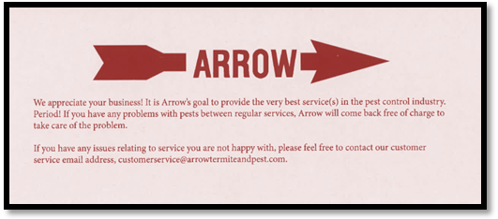

Service Procedures

Meetings
What have we done today to better serve our customers?

Daily
Check in Employees – each supervisor must meet with technicians that they supervise. Address for full day’s work, equipment issues, technician questions, review route. Each technician should be at the office by 7:00 a.m. and out no later than 7:30 a.m. If the technician has a truck or equipment issue that requires them to be at the office past 7:30 a.m. they should be given another truck. (No hanging around the office waiting)

Meetings
Manager and Office Manager(s)
- Pest control production
- Renewal production
- 5-year production
- Route efficiency
- GPS monitoring
- Customer issues
Have a short meeting with schedulers regarding:
- Route efficiency
  - Routes with accounts set up next door to each other
  - On the same street
  - In the same subdivision
  - In the same zip code
  - In the same town
- If there are account cancellations during the day, the scheduler will give the technician more work.
- Each scheduler will call their technicians 3 times per day to check on being on time, accounts being serviced, and if they need more work for the day.
- Daily schedules
  - What was on the schedule
  - What was complete
  - What type of services did they do
  - Are they on time to finish pest control
  - Are they on time to finish 5-years
- Review month to date production numbers for each technician

Pest Control Treatments Residential

Regular Non-Initial Treatment

Appearance
Be clean, neat, in clean uniform, shirt tucked in with next to top button buttoned, no chewing gum in mouth, not smoking, not eating, clean truck.

Equipment
Have all necessary equipment, proper chemical application equipment, sweep down broom, proper paper work, proper chemical mixed and agitated properly.
Drive up in your vehicle and park properly, remove keys, turn off vehicle.
Walk to door and knock on the door or ring the doorbell.
When the homeowner answers the door, say
Good morning/afternoon Mr. or Mrs. _____________. My name is _____________ from Arrow Pest Control. I am here to service your home for general pests.
I will sweep down the eaves of your home to remove cobwebs and dirt debris that are harborage areas for pests.
I will treat from the foundation out 6 to 8 feet from the foundation of your home and up the side of your home 1 to 2 feet including cracks around doors, windows, and weep holes and treat any ant piles in your yard. (Regular size yards only.)
Ask them if they having any interior pest problems. Go inside and spot treat any interior pest problems.
If wet after a rain, Tell them you will perform the sweep down, treat around eaves and windows with a liquid and treat around the perimeter 8 to 10 feet out with a moisture activated granule.

Lagniappe
We guarantee against roaches, ants, silverfish, and earwigs. Tell them they get additional non-guaranteed protection for areas treated for mosquitos, gnats, fleas, and flies.
After treating the exterior knock on the door, tell the customer you are finished. Go over what you did on the below checklist. Ask them if there is anything else, you can do for them while they are signing the work order. Ask them if they would like to pay by cash or ck. Try to collect when you are there. Smile
Thank them for their business.

Check List
- Knock on door
- Greet customer and explain what you are going to do.
- Sweep down eaves with sweep down broom
- Treat eaves
- Treat 8 to 10 feet out from foundation
- Treat ant piles in yard
- Addressed any other problems the customer made you aware of
- Performed a free termite inspection
Used 4 to 6 gallons around the home at low rate and 2 to 4 at high rate of concentration.
On initial treatments treat the interior of the home with baits and perform the outside treatment.
Customer Name: Tech Signature:
Knock on door. Greet the customer with a smile on your face (10-foot rule.) If someone is within 10 feet of you smile and greet them if they have not been greeted.

New Customers
Explain the Arrow 6 point pest control service plan at the door to new customers as well as inspect the home for their specific target pest problem and location as you perform an inspection.

Existing Customers
Explain the Arrow 6 point service plan each time you go out when you arrive and knock on the door. Always explain exactly what you are going to do at each customer’s home each time you service any home or business.
When you arrive, tell them you are there to service their home for (termite renewal, initial termite service, pest control, lawn control, etc.) and ask them if and where they are having any specific problems for the specific pest you are there to treat. Inspect and treat those areas first if the problem is an inside problem.
Explain our 6-point service at every stop.
- Arrow will sweep down all eaves on the exterior of the home providing for the physical removal of all live spiders, spider webs, and harborage areas for pests.
- Establish a 6 to 10 foot barrier around the exterior perimeter of their home including treating up the side of their home 1 to 2 feet including, weep holes, around window frames, door thresholds, cracks in sidewalks, doorframes, eaves of the home. The exterior perimeter treatment is performed with a mosquito suppression chemical. Although mosquitos are not included in our basic contract the chemical is effective against mosquitos
- Treat all ant mounds in the yard. Unlike almost every other competitor, the Management and Staff of Arrow do not believe that the control of dangerous fire ants should be an extra service at an extra charge. Arrow cares about the protecting the Health and Property of its customers. Ant control is included with Arrows basic service.
- Treat the interior wet areas such as kitchen, bathroom, around water heaters, wet bars, and attics on the initial and any time interior service is required with low impact baits, granules in the attic, and liquid spot treatments if necessary. If there is no problem with interior pests, explain to the customer you are there to establish a pest proof barrier around the exterior of the home. If they question why you don't treat the interior each time, explain unless it is the initial treatment or an interior problem exists Arrow does not make interior treatments. (Unless there is an interior pest problem)
- Ask the homeowner, would you like for me to bring any termite, lawn, or ornamental problems, pest problems I see while treating your home for (whatever service you are not performing at the home.) Inspect property for lawn and ornamental pests and lawn and ornamental problems. Inspect for lawn scalping, lawn insects, lawn diseases, lawn fungus problems, scalping with lawn mower cutting more than 1/3 of the grass blade, etc. Inspect property for active termites and termite conducive conditions.
- Report Findings back to each homeowner when you are finished. Knock on the door and explain: Mr. or Mrs.____I completed your scheduled pest control service I swept down the eaves around the home for spider webs, dirt and insects, treated 6 to 10 feet around the home, treated 1 to 2 feet up the side of the home including weepholes, window frames, door frames, thresholds, crack in concrete, all ant mound in the yard and noted these termite, lawn and ornamental plant problems on our home survey. Leave termite tips, lawn and ornamental tips with corresponding specials.
Note: If the customer does not have one of our services, be sure to tell them about our limited time specials. Example, Pest Control

$20.00 Special
The regular price is $165.00 for the initial treatment. We are running a limited time special of $20.00 on the initial treatment for a savings of $145.00 on the first service.

Termites
$50.00 off regular price on new initial treatments, not renewals, 5 years, etc.
Check with your scheduler to know the current prices of our other services like lawn care, ornamental care, and coming pool care.
- Mosquitos
- Ants
- Free Return Visits at no charge as many times as necessary.

Script Option 1
Good morning, afternoon. We are servicing several of homes in your neighborhood that have taken advantage of our $20.00 initial pest control special for roaches, ants, silverfish, and earwigs. I noticed (ant beds, ants, spider webs, spiders, any other pests. Name pest at ___________________location.
Would you be interested in having your home serviced today for your pest problems?
Get them to sign contract. Service the home at that time.
Collect check, cash, or pay by credit card for first and second service after service is rendered.

Script Option 2
Good morning, afternoon. We are servicing several homes in your neighborhood today for pest control. I noticed you have a name pest and location, (spider webs, wasp nests, ant, beds, and name location you see the problem at walking up to the door?)
Arrow is offering a $20.00 initial treatment special. Can I sign you up today and arrange for service?
Let me explain to you what our service does for other homeowners in the area with similar needs.

Daily Routine

Route Management
Scheduler - Technician Communication on non-serviceable, skip accounts.
All schedulers are to contact the technicians they schedule at least 2 times per day. All technicians are to contact their scheduler if they cannot service an account for any reason while they are at the account. $10.00 per account will be deducted out of each technician’s commission for each account not serviced/not called into scheduler. Some rescheduled accounts are to be expected. Not calling a scheduler at the account to notify the scheduler of the pending skip is not acceptable. All phones and radios are to be kept on each service technician’s person at all times. Do not leave your radio or phone in your truck while working. Schedulers are to keep track of every single time a technician does not call in a skipped account, and record the account customers name, date and time the non-service took place. At the end of each month, the number will be given to the manager. $10.00 times the number of un-serviceable/skipped accounts will be deducted from the next month’s commission. If a tech cannot contact the scheduler, they are to contact their supervisor. Do not call a supervisor first. (Exceptions will be made for after hours or special circumstances situations by the manager only.) After calling in the non-serviceable account, the scheduler will assign another account to the technician to be serviced in or around that time slot. Note: The deduction only applies if there is no call made to the scheduler.

Customer Relations

Complaint and Retreat Calls
When Customer Care Representatives take a call from a customer with a complaint they should help the customer evaluate the necessity of sending a technician back for a retreatment of their home.

Pest Control Complaints
If the complaint comes in the month of the service cycle, the treatment should be set up and the regular service performed with the complaint service, and the customer should be charged for the service. If the customer is seeing dead insects and no live insects, the customer care representative should explain to the customer that the previous service is working because the insects are dead, not alive and there is no need for a retreat. We will still go back if the customer is adamant that we go back out. In most cases the customer needs to know that they should wait at least 2 weeks before any retreat is performed. Exceptions to this rule are severe flea problems where the pest is causing great discomfort to the customer.

Termite Swarm Retreats

Phone, Verbal or Written Complaints
All complaints or inquiries should be answered completely and to the customer’s satisfaction.
Notes from customers on invoices, payments, surveys etc. regarding questions about them not seeing signs of treatment, not getting paper work, rude employees, employees not on time, etc. should be handled to the customer’s satisfaction. The Arrow representative that receives the complaint should go back to our G.P.S. system, locate the day and time the tech serviced the property and mail, email or fax a copy of the day and time we were on the property, blacking out all other stops on the report and all times if a question about service arises. We should show them the day and location only. Do not initially tell them we will check the G.P.S. because not all vehicles have G.P.S.s in them, furthermore G.P.S.s are not always operational. In all cases on all complaints, the Arrow representative should go to the technician and ask them what they remember about the home. If needed, send the tech back to the home to meet with the homeowner and explain what they remember about the home. If the homeowner is still not satisfied have the tech retreat the home to the customers satisfaction. Do not automatically offer to retreat the home. That will give the customer the impression that we did not treat the home and we condone that type of work. Any employee not servicing an account and issuing paper work that indicates they did treat the property in question will immediately be terminated.

Being On Time for Appointments
Representatives of Arrow are required to be on time all the time. If they are going to be late for any reason, they are to call their scheduler and supervisor so the customer can be contacted and told their service representative is running behind schedule. Representatives that do not perform this basic function will be terminated.

Sales Estimates
Estimates are to be made in a timely manner and followed up to a satisfactory outcome. I can’t get in touch with them is not acceptable. Follow up calls and site visits should be done.
After the sale and treatment. A site visit is required after each termite job sale and treatment by the sales associate. The sales associate should meet with the customer, perform a quality control inspection, and sales call for additional services. (The customer has to be at home.) Drill holes, trenching and treating, wall treatments, bath traps, and trenching should be according to label and state specifications.

Sales
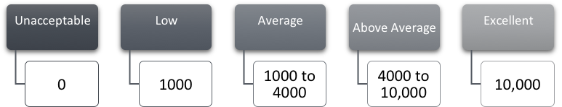
Sales are a function of each technician, secretary, supervisor, and manager. Every treatment performed is an opportunity to sell another service that we offer. Clover leafing, cold calling, cross selling, and lead generation are part of your job. Technicians that are motivated to sell have time to sell. Technicians that are not motivated to sell have no time to sell. Minimum wage employees at the largest hamburger chain in the world ask every customer 100% of the time if they want fries with their hamburger. Why can’t all service technicians ask 100% of the time if a customer needs a service we do not presently provide after inspecting and being able to bring to the customer’s attention the need for additional services? Monthly sales by service technicians are as follows:
All technicians are expected to sell as part of their job. Selling is asking.
Effective sales approaches include:
- Looking for conducive conditions or homeowner problems relating to their need for our services such as evidence of spider webs or ant mounds. If you are performing a termite renewal, why wouldn’t you bring spider webs and ant mounds to the attention of a current customer?
- Be, feel and sound sincere about helping a customer with a problem.
- Leave information and literature with your name on it. Follow up with the customer.
- Know your services. Being knowledgeable gets you over the “fear factor.”
- You can’t screw up anything you can’t unscrew. Make the sale. If you make a small mistake on pricing write it up as a learning experience.
- Meet your individual sales and service goals for the month.

Collections
Technicians are to collect as part of their job. On all pest control accounts, the tech is to present a bill for services rendered after the service is performed that list the amount due. They are then to ask if they would like to pay by cash or check.
Try to collect at time of service.

Training Protocol and Tests

New Employee Training
All new employees should be familiar with below listed items.
- Ride with treater
- Termite
- New termite jobs
- Renewals
- 5 years
- Booster treatments

Day One

New Employee Packet
- Training material for state test
- Read label personal hygiene

Personal Hygiene
- In uniform
- Black shoes, white t-shirt
- Shirt buttoned all the way except top button, clean uniform, black socks
- State I.D. on shirt
- Clean hat
- Bathed, clean shaven

Other
- Yes sir, No sir, Yes ma’am, No ma’am,
- The 10-foot smile rule. Always smile when you are within 10 feet of someone.
- Hair neat
- Men, no piercings, no earrings
- Bathed, clean shaven

Safety
- Rubber gloves to be washed and rinsed by you as needed. If they become wet inside it is up to you to turn them inside out, wash them and let them dry out. Do not get another pair unless they are worn out.
- Safety Glasses
- Respirator
- Fit test with safety equipment

Paper Work
- As instructed by trainer on each job
- Work order, fill out correctly
- Renewal survey
- Door knocker - how to clover leaf next the home and the three homes across the street.
- Arrow sticker to be placed on utility meter if one is not on the utility meter
- Pest control contract

Treatment Procedures and Inspection Procedures
- Dig 4 by 6 inch trenches on termite jobs, 5 year, booster job
- Cut bath traps, know how to operate hand sprayer.
- Rod around a home on a renewal every 2 inches.
- Do paper work 5g. Cac. Correct percentage.
- Inspect home and fill out a termite renewal survey.
- Go over renewal survey conducive conditions.
- Mix chemical, tank 1/3 full. Read mixing instructions on label.
- Agitate chemical
- Perform actual treatments while being observed by trainer after being shown treatment procedures by trainer you are riding with.
- Drill, treat and plug a drill hole drilled exactly every 12 inches.
- Sweep down eaves with sweep down broom.
- Treat 8 to 10 feet around the exterior perimeter of each home, structure.
- Treat around windows, window sills, not on glass panes, door stoops, up two feet
- From ground level up the side of the structure.
- Treat the interior with baits and only utilizing liquids as a spot treatment in hard to control areas.
- Treat yard for ants placing 1 to 2 cups on each ant mound in the yard area.
- Treat around playground equipment, cracks in sidewalks and driveways, doorsteps, eaves, or any other insect harborage areas.
- How much do we charge for the initial and ongoing quarterly service contract?
- Read chemical label
- How do you mix chemical listed under mixing instructions? 1/3 full.
- Is paper work correct? Chemical percentage, amount, chemical type.
- Did you perform a termite inspection and list termite conducive conditions on a termite renewal survey? Why do this. Issue termite estimate.
- Agitate chemical before applying and while mixing.
- Familiarize with communication equipment.
- Become familiar with schedules, invoices, doorknocker, and stickers for meter boxes.
- Read tech training manual while riding with trainer for test.

Day 2 - Termite Training

NPMA
- Safe driving manual, read and take tests
- Don’t write in book
- Check answers

NPMA
- New technician training manual
- Take tests
- Don’t write in book.
- Check answers
- Florida disk

Treating Name: Date:
Monolithic Slab Foundation Service Tech I.D. No.
- What is an expansion joint?
- What is a cold joint?
- What is a stress crack and why should it be drilled?
- What is a solid monolithic concrete slab pour?
- What is pier construction?

- How far apart do you drill holes when drilling expansion or cold joints?
- What are the dimensions of a trench on the exterior of a home?
- How does one fill in drill holes with concrete patch?
- Why do you always look at the graph before treating a newly sold home?
- Why do you never start a job unless you have paper work?

- How do you calculate linear footage?
- How many gallons of finished solution do you use per 10 linear feet?

- How do you calculate square footage?
- How many gallons do you use per 100 square feet on a pretreat?
- What is a colony elimination termite chemical?
- What is a spot treatment?

Pier Construction
- What is a monolithic slab foundation?
- How do you treat a solid pier on pier type construction?
- What type of piers do you have to drill?
- Where do you drill a pier?
- What is pier and beam construction?
- What is a crawl suit and why should you have one on your truck?
- Why list every Imidacloprid chemical such as Dominion, Premise, Imid, etc. as Imidacloprid on the label?

Safety Equipment
- What are safety glasses?
- When do you wear safety glasses?
- What are unlined chemical proof gloves?
- When do you wear unlined chemical proof gloves?
- What is a long sleeve shirt, and pants and when do you wear it?
- What is a respirator?
- What is spill cleanup material?
- Why do you always keep chemical under lock and key?

Chemicals
- What do mixing instructions say on every chemical label?
- What is LD50?
- Why is it important to always read the chemical label

Scheduling of Accounts
Schedule accounts as close together as possible. Start by street, subdivision, area, zip code, town, geographical area, etc. If in a rural area, start from first account and go out from that account in mile increments. Always pay attention to customer needs and wants.
Place any notes regarding time of service, customer needs, and service related instructions in computer.
Important: all homes that require special considerations such as customer being at home at time of service, dogs in back yard that have to be put up before service is rendered, or locked gates that have to be left unlocked have to be scheduled at the first of each month. If schedulers cannot contact the customers with special considerations during regular working hours they are required to occasionally come in to work 30 or 60 minutes later, and work 30 minutes to 60 minutes later each day so they can contact these customers in the late afternoon hours after the customer gets home from work. Schedulers should also make it a point to call and schedule.
If a new technician goes to an account, they need to have all service instructions available each time they go out. Detailed service instructions including service times, special service requirements and needs, start points, etc. have to be printed on service schedule.

Technicians and Schedulers
If instructions say to call the customer while you are on the way you need to call them. If for any reason, the tech cannot call the customer they need to immediately call their scheduler. Reasons for calling the customer include but are not limited to the customer unlocking their home, opening gate, putting dog up, talking to tech, etc. Not calling a customer inexcusable. Techs should keep radios on their person, body at all times so last minute changes made by customer can be relayed to tech from scheduler. Radios should also be turned on at all times.

Rescheduling
If for any reason an account cannot be serviced the technician must immediately call their scheduler so the account can be rescheduled. Period, no exceptions. A valid reason must also be given why the account is not finished in detail immediately to the scheduler and written on the service order so the techs written reason for not performing the work will be in writing. The time of the call to the scheduler and who they talked to will also be written on the work order. The tech may be required to work additional Saturdays to finish rescheduled work. All rules apply to all techs, schedulers, and supervisors. If you “turn in” blank work orders with your paper work you are subject to being terminated. Paper work “turn ins” are not acceptable without valid reason and notification. Unhappy un-serviced, non-notified customers will not be acceptable.
All pest control is to be finished within the first 3 weeks of the month. If you finish your schedule early, you must call the office for more work.
If you are a full time scheduler and are scheduling do not place an account on a schedule that takes a technician out of their scheduled area by an inordinate amount of time. Pay attention to the area the technician is working in.
Scheduling of any account that require the homeowner to be at home when service is rendered, high balance accounts that require a phone call asking that the past balance be paid when service is provided with a check or credit card, or special service requirement considerations will be made before the 15th of each month.
Every effort will be made to pay for all new services by credit card. When selling the account the sales person will ask the new customer, “And what credit card will you be making payment with.” They need to understand that the credit card number will be kept on file and the card charged when service is rendered.
Rescheduling of accounts because of rainouts. Rescheduling of accounts because of rainouts should be done the next day. Each morning, check the next day’s weather. Keep that in mind while scheduling. When talking to or leaving a scheduling message for a customer, be sure to tell them you are scheduling service for the next day. If a problem, including inclement weather is a problem Arrow will come out the next day.

Sample Scheduling Script
Hello, this is ___with Arrow Pest Control. It is time for your regular pest control service. We will be out to service your home on (Date). Please put up any animals on this day leaver your back gate unlocked. If you have any questions Please free to call me at ___. (Phone Number.) If we service during or after inclement weather, we will utilize moisture activated granules in the yard area.
In addition to calling the customer, email the customer letting them know what day and time we will be out with special instructions on gates, dogs, etc. (If the service does not already include a mosquito suppression treatment as part of their regular service.)
For a limited time only we are offering a mosquito suppression treatment for only $35.00 extra. Please call us if you would like this service included with your regular pest service.
Be Polite, But. Your job is not to ask if you can come out to render service. Your job is to TELL the customer Arrow is coming out to perform the regular service. When the customer signed the contract, they knew Arrow would be servicing on a regular basis. Your call is a courtesy notification call only.

Scheduling of Pretreats
Complete information on the builder and owner including phone numbers and addresses, square footage, water on site, treatment day and time should be collected. Additionally, when the original pretreat is called in the builder should be reminded to call us before any flat work that abuts the exterior foundation is poured so the joint that abut the exterior foundation can be treated. (Termites can access a home through an untreated joint or any crack as small as 1/70th of an inch.)

Scheduler Training Aids
Scheduler Guidelines for Scheduling

Scheduler Goals
- Limit Travel Time to 50 miles driving time from the technician’s first stop of the day to the technician’s last stop of the day.
- Limit travel time between stops to 3 minutes.
- Schedule an average of 16 stops a day.
- Help technicians meet their production goals. $12,000 in pest control for pest technicians plus renewals per month. $30,000 dollars for each termite technician. $40,000 for each termite technician that has a helper.
- Schedule all work completely and professionally.
- While scheduling work, make the customer aware of any add on services such as mosquito suppression, termites services, etc.
You are to never reschedule a day’s work without the permission of Mike Cohn.

Additional Training Information
Scheduling Secretaries and any Person That Schedules Pest and Termite Work.
Techs are to be on time and prepared for work. Write down any customer complaints and give to Mike Cohn. Our company will be the very best in the industry. Period.
If a tech does not show up for work on a given day it is the responsibility of the supervisor or manager to find someone to run the absent techs route on that day.

Talk to customers with smile on your face!
When calling a customer to set up service be sure to include the following:
Hello, my name is (Your Name) with (Company Name).

Scheduling Pest Control
I am calling you to let you know we will be out on DATE AND TIME to render your quarterly/every other month/monthly pest control treatment. Please put up all dogs on this day and leave any locked gates open. We greatly appreciate your business. It is our goal to be the very best provider of termite and pest control services. If you have any problems after the service is rendered, please call our office and ask for me, your name. Thank you and have a great day.

Scheduling Termite Work
Termite Renewals
Hello, my name is (Your Name) with (Company Name).
I am calling you to schedule your termite renewal inspection on Date between the hours of 8a.m. and 8p.m. You do not have to be home for the termite renewal service. Please put up all pets and leave all gates open on this day. We greatly appreciate your business.
If you have any problems or questions after the service is rendered, please call our office and ask for me, (Your Name). Thank you and have a nice day.

Initial Termite Treatments.
Hello, my name is (Your Name) with (Company Name).
I am calling to schedule your termite treatment sold on. We would like to come out on date.
If we need access to the interior for treatments such as bath traps, interior drilling, etc. give them a date and approximate time. Give no more than a two-hour time frame, unless you have to such as, we will be out between the hours of 8a.m. and 10a.m. If we do not have to treat the interior or the home just give the DATE we are trying to schedule for, between the hours of 7a.m. to 8p.m.

Customer Needs to Be Home
When no interior treatment or interior treatments such as bath trap cutting and treatment have already been performed by the salesman and we need access to the interior of the home. (When we need access to the interior of the home.)
We would like to come out on date to perform the termite treatment on the interior and exterior of your home. If this date is not convenient, please call me at my office at (number), so we can schedule a time that is convenient for you. We greatly appreciate your business. If you have any problems or questions after the service is rendered, please call our office and ask for Your Name. It is our goal to be the very best provider of termite and pest control services. Thank you and have a great day.

Customer Does Not Need To Be Home
When interior treatments have already been performed and we need only to treat the exterior perimeter.
We would like to come out on date between the hours of 7a.m. and 8p.m. to complete the termite treatment on your home. You do not need to be home for the treatment to be completed. Please put up all pets and leave all gates open on the service date. We greatly appreciate your business. It is our goal to be the very best provider of termite and pest control services. If you have any problems or questions after the treatment is rendered please call me at phone number. Thank you and have a great day.

Scheduling Review
Name: Date:
- How do you determine how to schedule accounts?
- List the geographical breakdowns of scheduling
- How many accounts can be scheduled in a days’ time if set up in a subdivision or small geographical area:
  - Residential Pest Control____
  - Residential Termite Renewals____
  - 5 year Treatments on Average Size Homes____
  - Initial Termite Treatments on Average Size Homes
- How many termite residential renewals should a pretreater do per hour if he or she does not have pretreats to do?
- How long does it take a scheduler to scheduler to schedule 16 residential pest control accounts?
- What do you say to a customer when setting up a pest control service?
- Why do you not ask a customer if you can set up their pest control service?
- Why is it important to have all high balance or special account consideration accounts serviced before the 15th of each month?
- Why is it important to record the email addresses of each new customer in the computer when the account is sold?
- When should pest control account with locked gates, dogs, or customers that request service when they (the customer) is home be called if contact cannot be made during regular working hours?

Daily Meetings and Daily Task Sheet for Managers.

Daily Check In
- Meet with each technician on a one on one basis or tele-distance.
- Review yesterday’s paperwork, percentages, signed, chemical types, EPA numbers, and renewal survey on every home.
  - Accounts scheduled
  - Accounts done
  - If there were skips or extra time did the technician, call his or her scheduler and get extra work.
- Doors Knocked
  - Number of Doors Door Knockers put out on. (At least 5 per stop on homes 2 side and three across the street.)
- Number of Sales, Number of People Approached
- Discuss Customer Exceptions Like I will talk to my husband, wife, think about it, etc. The prospective customer needs to know that there is a limit on time.
- PIG, Program Referral
- What are you going to do today to better serve our customers?
- What are you going to do today to sell something?

Supervisors or Managers should meet daily with the following:
- Technicians
- Sales Associates
- Schedulers
- Pretreat Technicians, out of town workers that work alone that do not have contact with a supervisor, or any person without a full schedule. Schedules will be monitored throughout each day, but more specifically each afternoon for the next day and the next morning. Be sure they have a full schedule, are at work at the required time, on time for appointments, and are BUSY throughout the day. Meet with the respective schedulers, let them know they should review the schedule with you each afternoon for the next day, review and be sure these people are busy. Examples: Lafayette workers, Houston workers, Pretreaters, Houma. Salesman. Workers or any worker that does not come to office each day.

Daily Meeting

Field Supervisor Talk
Every Day

Location
Area where techs can sit down for 2 to 3 minutes in the office.

Criteria to Go Over
Every service should be on the level of a work of art. It should be priceless.
Be sure your troops are better prepared than every other companies are. Say something motivational.
Have a quick 2-minute meeting with everybody. Go over some of these items every day. Every 3 or 4 days you should have covered all items.
Uniform clean tucked in, truck clean, equipment clean, chemical, paperwork all in order so techs do not have to return to office for anything.

Tell All In Meeting
Are you ready to do your job, do it right, do it complete and do it better than any other company in the pest control industry. If you have any problem at any job, call your supervisor and scheduler with any problem.
Knock on the door at each home and properly introduce yourselves and what you are there for. After the job is done ask the customer if there is anything else you can do for them. Say...If you have any problem please call us, we will come back at no charge. Thank them for their business while looking them in the eye being professional, in uniform, etc.
Call your scheduler when you get to each account or stop and when you leave, no exceptions.
If you do not complete your work, you will be required to finish it on the weekend. Do not turn in any unfinished work tomorrow or any other time and make an excuse why it could not be done.
Do pest control right, your renewal right, and all termite work right.
If you are a pretreater, have a full day of renewals to do if you do not have pretreats. That is at least 16. Do not ride back to this office to pick up renewals. Riding back to the office is a waste of time. You are not servicing customers; you are wasting productive time, wasting gas, and creating unnecessary wear and tear on a company vehicle.

Selling
Knock on doors put out doorknockers and sell something. That is your job.
Do not go home after you last stop before 5 p.m. If you finish early, call in and get more work from your scheduler.
Do not go out of area for any reason in Arrows truck. You will be fired for doing it, no second chances.
Answer all questions completely if asked by a customer. If you do not know the answer, talk to your supervisor. Get the right answer. Address customers as yes ma’am, no ma’am, yes sir, no sir. “Yeah” is not acceptable.
Ask them. Are you ready?
Meet with schedulers after techs are out. Go over schedules.
Call on at least five new potential customers per day. Six month old. Residential Treen Reports, Dodge, New Businesses, Existing Businesses, old renewals, old pest control, commercial accounts, realty trac foreclosures, Sunday paper real estate for sale, LoopNet, newly treated homes quality control check for pest or renewals, pretreated homes making contact for perimeter treatments and leaving perimeter notices on doors, etc. Get with lead secretary for lead sources that you collate by area, zip code, street, subdivision, etc.
Check at least two techs in the field each day.
At 10 a.m., 2 p.m. and 4:30 p.m., if not more often call each technician, be sure all accounts are being done, be sure their schedule will be completed, and check to see what they have sold that day.

Sales Meeting
The sales meeting should include the previous day’s sales leads, sales, number of leads to sales, today’s sales leads, percentage of sales to sales leads, etc. Sales leads, cold calls, and other types of calls will be reviewed from the previous day as well. Names of cold call leads should be reviewed. Sales and sales approach should be reviewed. Cold Call Leads should come from but not limited to 6-month-old residential and commercial dodge reports, treen reports, bid clerk reports, realty trac reports, bid loop reports, etc. Cold call leads should be given out by sales manager each day.

Meetings, Checklists, Schedulers

Scheduler Meetings with Management
Schedulers should be able to schedule effectively and timely. It is not up to management to do their job for them. It is up to management to give direction, train, follow up, and set quality control standards.
- Are accounts set up by street, subdivision, zip code, town, as close together as possible with as little drive time as possible?
- Are accounts set up by saying we will be at the scheduled visit not at specific time but between the times of say 1p.m. to 2p.m.
- Are schedulers addressing customers properly?
- Is the scheduler getting an inordinate amount of non-serviced stop service tickets from techs?
- Is there an inordinate amount of complaints on any particular tech? What are complaints about? Is the scheduler passing complaints along to the techs supervisor?
- Is the scheduler placing a follow up call to all new accounts, service call or complaint accounts, and a sampling of regular accounts each day and filling out proper documentation?
- Are techs finding all their accounts and do they have proper equipment and supplies?
- Are techs making too many trips back to the office? They should leave in the morning and not come back until all accounts are completed, not before 5p.m.
- Are all techs putting out door hangars on the homes on each side of each serviced account and the 3 across the street from the account, quality control statements, paper work, etc. at each account?
- Check scheduling info from visual routing?
- Will pest control be finished by the end of the 3rd week of the month?
- Are techs working required Saturdays?
- Are techs working on Saturdays making up missed days?
- Are any techs missing an inordinate amount of days?

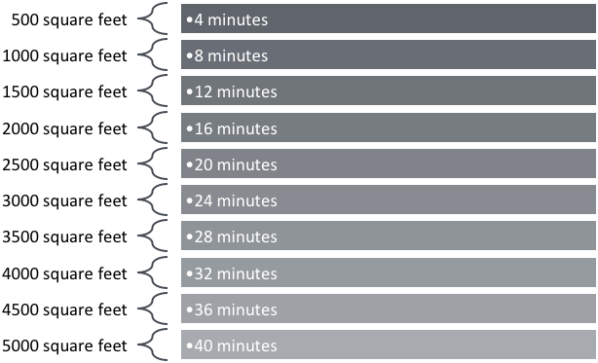
Pre-treat Training and Timing
Pretreat Timing on 500-gallon trucks that pump at least 15 gallons per minute.
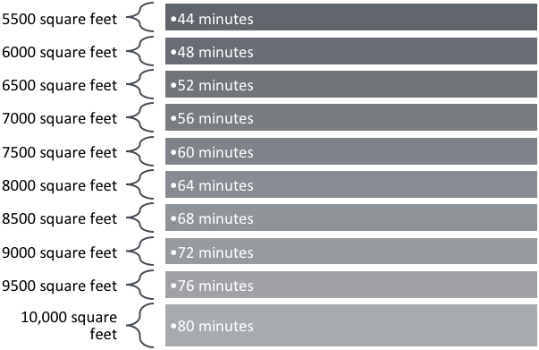
If you have a 500-gallon tank, you need to fill up at this point. Pretreats that are over 5000 square feet and done with Dominion, Imidacloprid need to refilled at the low .05 rate.
The .10 rate is double the chemical, half the water. Example: If treating 1000 square feet use 50 gallons of water with 27.5 ounces of dominion chemical. It gives the .10 rate.
It should take no more than 20 seconds to fill up a 5 gallon bucket at this rate. That is 15 gallons per minute. Don’t treat any foundation unless totally graded. The workers in the area you are treating need to be told to get off the foundation.
If a no charge borate to wet areas in the structure is added, a borate besides bora care is to be applied to the bath and kitchen wall studs (Do not apply or accidentally apply borate to tubs, sinks or to anything except wooden wall components. It should be applied at the dried in stage of construction before insulation and sheet rock is installed. At the same time, perform the perimeter. If the perimeter cannot be done, at least treat the joints where any flat work is to be put in.

Field Supervisor Checklist
- Wildlife control and removal protocol
- Price job for trap placement and reinspection of the trap intervals.
- Go to home or business. After inspecting, identify areas that need to be wildlife or rodent proofed and urine or other damaged areas.
- Give additional estimate on added wildlife proofing, rodent proofing, insulation removal, and replacement where feces or urine has been deposited on the insulation with one-year warranty with renewal.

Bank Owned and Homes for Sale

Empty Homes
- Place a sticker on the utility meter.
- Place a sticker or decal on the storage room window.
- Place at least two business cards between the screen and window with an estimate for termite and pest control.
- Leave a door hangar or promotional material at the front door.
- Slide a business card under the front door or in the mail drop at the front door. (Do not leave a business card in the outside mailbox.)
- Optional
  - Place a monitoring station with, company name, phone, web site and the phrase, “For Service Call” close to the front entrance of the home.
  - Place an Arrow magnet on the outside air conditioner.

Occupied or Recently Sold Homes
- Knock on door and try to sell the homeowner our services.
- If not home, leave a doorknocker.
- Place a business card in between a window and screen on at least one window.
- Leave an estimate for termite and pest control services.

Preforeclosure
- Leave a card between a window and screen.
- Place sticker on utility meter.
- Place doorknocker on front door.
- Insert a card in front door mail slots only with doorknocker or promotional material.
- Leave an estimate for termite and pest control services.
- An option to stickers is placing a company name, magnet on the utility meter with our company name.
Note: Place a home value in the system on homes to contact. A $70,000 home probably would not have a homebuyer that would buy or services. Use your best judgment based on your area subdivisions, consumers, and buying habits.

Commercial - All Categories
- Place sticker on utility boxes unless a small commercial with only one owner.
- Place cards under every door where the space is unoccupied or no one is there.
- Leave a doorknocker on the door.
- If there, talk to the business owner.
- Optional
  - Leave a monitoring station close to the front door where there is a lot of foot traffic.

Salesmen on cold calls for the following services when schedule has gaps:
- Realty Trac-bank owned/Repos
- Direct Data List
- Treen Reports/Dodge Reports
- Pretreat Additions
- Past due renewals, 5yrs, pest control
Schedule according to existing timed appointments.
At each one:
- If homeowner is present, re-sell services!
  - Renewals, 5yrs, and pest control!
- Place sticker on utility box.
- Install one station with arrow’s name on it in flowerbed by front door, such that anyone walking to the front door can clearly see arrow pest control on the station.
- Place magnets:
  - On refrigerator if arrow representative goes inside home
  - Under front door
  - In mail drop box inside door
  - On windowsill
- If no one home, put door-hanger with business card
- Trash cans and recycle bins:
  - Put sticker on both outside and inside.
  - Use red & white arrow sticker & fly treatment sticker.
- For realty trac properties, also put two business cards inside each screen on front windows of home, and leave a proposal with business card and insert. Follow realty trac pricing guidelines set by Mr. Mike.
Drive to first customer’s home with the thought in mind to provide the very best service in the world and by virtue of providing world class, make a great impression service you can cross sell other services.
Greet the customer with a smile on your face. (10-foot rule.) If someone is within 10 feet of you smile and greet them if they have not been greeted.

New Customers
Explain the Arrow 6 point pest control service plan at the door to new customers as well as inspect the home for their specific target pest problem and location as you perform an inspection.

Existing Customers
Explain the Arrow 6 point service plan each time you go out when you arrive and knock on the door. Always explain exactly what you are going to do at each customer’s home each time you service any home or business.
When you arrive, tell them you are there to service their home for (termite renewal, initial termite service, pest control, lawn control, etc.) and ask them if and where they are having any specific problems for the specific pest you are there to treat. Inspect and treat those areas first if the problem is an inside problem.
Explain our 6-point service at every stop.
- Arrow will sweep down all eaves on the exterior of the home providing for the physical removal of all live spiders, spider webs, and harborage areas for pests.
- Establish a 6 to 10 foot barrier around the exterior perimeter of their home including treating up the side of their home 1 to 2 feet including, weep holes, around window frames, door thresholds, cracks in sidewalks, doorframes, eaves of the home. The exterior perimeter treatment is performed with a mosquito suppression chemical. Although mosquitos are not included in our basic contract, the chemical is effective against mosquitos.
- Treat all ant mounds in the yard. Unlike almost every other competitor, the Management and Staff of Arrow do not believe that the control of dangerous fire ants should be an extra service at an extra charge. Arrow cares about the protecting the Health and Property of its customers. Ant control is included with Arrows basic service.
- Treat the interior wet areas such as kitchen, bathroom, around water heaters, wet bars, and attics on the initial and any time interior service is required with low impact baits, granules in the attic, and liquid spot treatments if necessary. If there is no problem with interior pests, explain to the customer you are there to establish a pest proof barrier around the exterior of the home. If they question why you don't treat the interior each time, explain unless it is the initial treatment or an interior problem exists Arrow does not make interior treatments. (Unless there is an interior pest problem)
- Ask the homeowner, would you like for me to bring any termite, lawn, or ornamental problems, pest problems I see while treating your home for (whatever service you are not performing at the home.) Inspect property for lawn and ornamental pests and lawn and ornamental problems. Inspect for lawn scalping, lawn insects, lawn diseases, lawn fungus problems, scalping with lawn mower cutting more than 1/3 of the grass blade, etc. Inspect property for active termites and termite conducive conditions.
- Report Findings back to each homeowner when you are finished. Knock on the door and explain: Mr. or Mrs.____I completed your scheduled pest control service I swept down the eaves around the home for spider webs, dirt and insects, treated 6 to 10 feet around the home, treated 1 to 2 feet up the side of the home including weepholes, window frames, door frames, thresholds, crack in concrete, all ant mound in the yard and noted these termite, lawn and ornamental plant problems on our home survey. Leave termite tips, lawn and ornamental tips with corresponding specials.
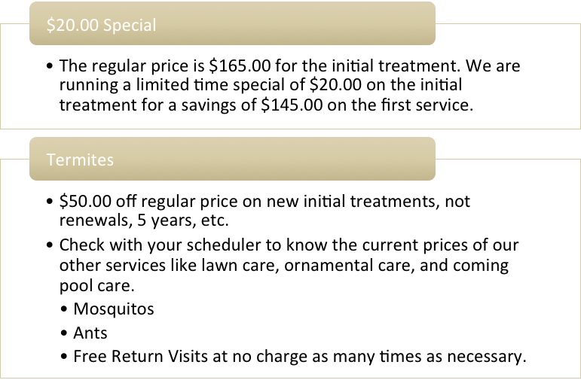
Note: If the customer does not have one of our services, be sure to tell them about our limited time specials.

Good morning, afternoon. We are servicing several of homes in your neighborhood that have taken advantage of our $20.00 initial pest control special for roaches, ants, silverfish, and earwigs. I noticed (ant beds, ants, spider webs, spiders, any other pests. Name pest at __location.
Would you be interested in having your home serviced today for your pest problems?
Get them to sign contract. Service the home at that time.
Collect Check, Cash, or pay by credit card for first and second service after service is rendered.
Good morning, afternoon. We are servicing several homes in your neighborhood today for pest control. I noticed you have a name pest and location, (spider webs, wasp nests, ant, beds, and name location you see the problem at walking up to the door?)
Arrow is offering a $20.00 initial treatment special. Can I sign you up today and arrange for service?
Let me explain to you what our service does for other homeowners in the area with similar needs.

WDIR Reports
WDIR Reports represent the largest source of lawsuits in the pest control industry. Before any report is given to a customer, real estate agent, or real estate closing person or anyone else, the property should be thoroughly inspected, inside and out, including attic spaces. One should error on the side of caution. If something looks like damage, put in on the report. The Statement
By signing this document, the Buyer/Seller understands that Arrow is not responsible for hidden termite damage; any dispute regarding hidden termite damage is to be resolved by Buyer/Seller, not Arrow Pest Control. Note: This is important, do not forget this.

Inspections of properties requiring a WDIR

Not under contract with Arrow
Be suspicious of homes not under contract. You may be inspecting a home with active termites, a home where the owner or realtor has scraped tunnels off the home, a home where termite damage has been covered up or painted over, a home that was inspected and turned down by someone else and then the homeowner called Arrow after removing evidence of a termite infestation, etc.
Photos should be taken of exterior slab of the home, etc.

Wildlife Control Estimates
Price basic trapping over the phone if possible for trapping only. Tell them we will price the exclusion work and repair or replacement of insulation because of urine or fecal stains and cleanup of feces or urine when we go to the job.
Supervisors and management are responsible for every technician performing their job on time, professionally, completely, and correctly. Supervisors are to call the technicians twice daily, once before lunch and once around 4 o'clock. The first question a supervisor asks will be "What are you doing to better serve the customers you have serviced today?" The supervisor will then ask about any problems, service issues, any reason why Arrow is not performing superior service, being on time, any accounts that could not be serviced for any reason, and confirm that all accounts will be done completely and professionally by the end of the day. If there is a problem, you fix it.

Forms

Arrow Field Quality Control Form (Internal Use Only!)
Supervisor Name: ____ PMP: ____ Acct #:__
Supervisors and management are responsible for every technician performing their job on time, professionally, completely, and correctly. Supervisors are to call the technicians twice daily, once before lunch and once around 4 o'clock. The first question a supervisor asks will be "What are you doing to better serve the customers you have serviced today?" The supervisor will then ask about any problems, service issues, any reason why Arrow is not performing superior service, being on time, any accounts that could not be serviced for any reason, and confirm that all accounts will be done completely and professionally by the end of the day. If there is a problem, you fix it.

Professionalism, Equipment, and Safety
- Was the PMP on time? □ Yes □ No
- What label have you read recently? _______________
- Was PMP wearing the proper uniform of black belt, black shoes, long sleeves, pants, and hat? □ Yes □ No
- Uniform tucked in? □ Yes □ No
- Does PMP have treatment tool capable of fan spray, straight stream, and rodding?
□ Yes □ No
- Did the PMP clearly greet the customer and educate them about the service that was going to be rendered? □ Yes □ No
- Is the truck clean on the inside and out with no exposed chemical containers/equipment? □ Yes □ No
- Did the tech utilize all necessary safety equipment? □ Yes □ No
- Was the paperwork clear, accurate, and legible? □ Yes □ No
- Does PMP have a spare tire kit? □ Yes □ No
- First aid kit, spill kit, spare tire kit? □ Yes □ No
- Does PMP have radio and charger? □ Yes □ No
- Proper GPS to locate jobs? □ Yes □ No

General P/C
- Sweep down performed? □ Yes □ No
- Yard inspection performed? □ Yes □ No
- Fan spray used as an 8 ft. barrier out and 2 ft. up on home with treating all exposed voids and eaves? □ Yes □ No
- Was any inside service performed? □ Yes □ No
- What pest was the problem on inside?
- Were any pest/termite conducive conditions along with tips relayed to the customer? □ Yes □ No

Termite Renewal
- Was a termite renewal survey filled out identifying conducive conditions? □ Yes □ No
- Were the rod holes 2-4 inches apart? □ Yes □ No
- Were the monitoring stations FLUSH TO GROUND, checked, or put down and replaced? □ Yes □ No
- Was the yard inspected and treated for ant mounds? □ Yes □ No
- Porch columns and beams rodded and treated along with any unsealed windows?
□ Yes □ No
- Was the paperwork filled out correctly with conducive conditions, tips, and “TAT”?
□ Yes □ No

Termite Job
- Was the graph and measurements of the house, chemical, and drilling double checked by PMP? □ Yes □ No
- Was the trench 4 inches wide and 6 inches deep? □ Yes □ No
- Were the proper waivers signed for bath-traps, rodding, etc…? □ Yes □ No
- Were the drill holes a maximum 12 inches apart? □ Yes □ No
- Were the drill holes properly sealed? □ Yes □ No
- Was yard treated for ant mounds? □ Yes □ No
- If there were active termites, were they spot treated with Termidor and noted on paperwork? □ Yes □ No
- Did PMP walk client around home to show them the quality of work and what they paid for? □ Yes □ No
- Was a $1 or $20 initial pest control special offered to homeowner at the time of treatment? □ Yes □ No

Sales/Marketing
- Was there any attempt to cross-sell or offer add-on services? □ Yes □ No
- Was a quote for an additional Arrow service left on the paperwork? □ Yes □ No
- Was an Arrow sticker applied on the outside A/C box? □ Yes □ No
- Was there an attempt to cloverleaf or door knock surrounding homes/neighbors? □ Yes □ No
- Has the PMP sold anything in the past week? □ Yes □ No
  - What?
Notes:

Scheduler Checklist
Scheduler Name:
Date:
Number of new accounts completed:
Number of new accounts followed up on:
New Sales Leads:
New Sales Sold:
Source: TV □ Post Card □ Website □ Yellow Pages Book □ Yellow Pages Online□ Billboard □ Office Correspondence □ Newspaper □ Other:
How many complaint calls were taken?
Was the complaint service or technician related?
Reason for complaint(s). List each complaint separately.

Were all complaints followed up on? □ Yes □ No If no, why?
Resolution:

Total number of rescheduled for your technicians:
What can Arrow do to better serve its customers each day?

Follow Up Calls
***Follow up on all NEW accounts serviced 2 days ago. ***
***Follow up on all service calls and complaint calls. ***
Account Type: □ New □ Existing
Customer Name: Account #
Service Date: Scheduler:
Call Date: Service Type:
Address:
Technician:
Was the technician dressed professionally? □ Yes □ No
Was the technician courteous? □ Yes □ No
Did the technician have all needed supplies? □ Yes □ No
Were you happy with the service? □ Yes □ No If no, why?
Customer comments:

Verified: □ mailing address □ Home number □ Work number □ Cell number

Form 1 – Waiver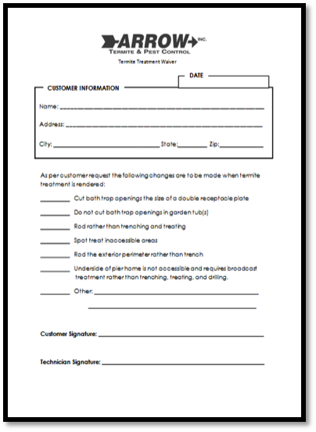 | Form 2 – Pest Contract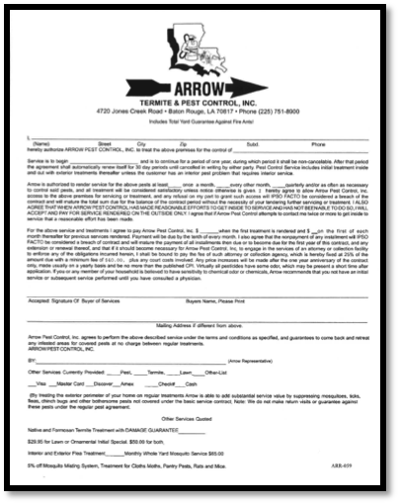
Form 3 – Service Checklist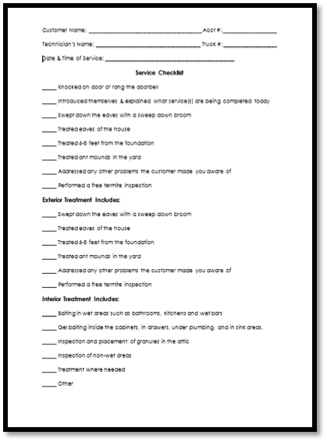 | Form 4 – Renewal Survey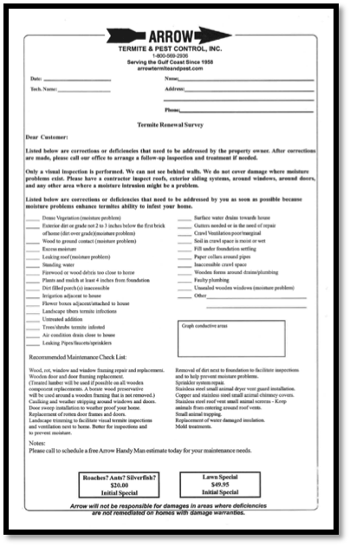
Form 5 – Termite Graph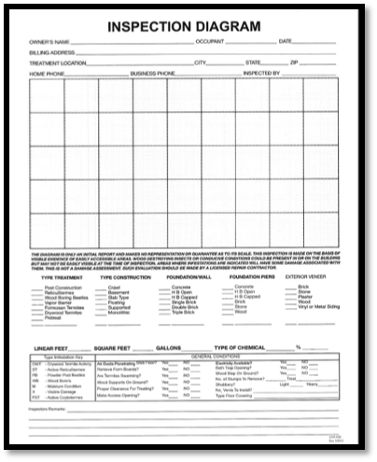 | Form 6 – Estimate Proposal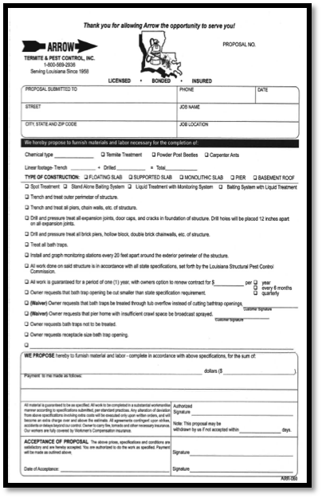
Form 7 – Sticker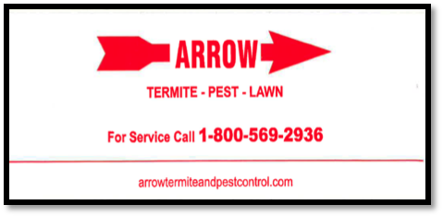 | Form 8 – Service Statement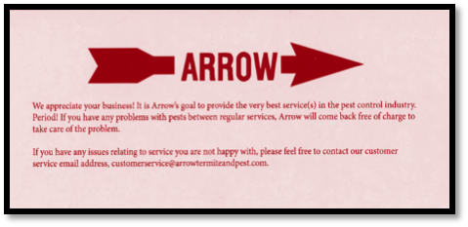

Service | Form 1 Waiver | Form 2 Pest Contract | Form 3 Service Checklist | Form 4 Renewal Survey | Form 5 Termite Graph | Form 6 Estimate Proposal | Form 7 Sticker | Form 8 Service Statement
T-job | ✓ |  | ✓ | ✓ | ✓ | ✓ | ✓ | ✓
Booster | ✓ |  | ✓ | ✓ | ✓ | ✓ | ✓ | ✓
5-year | ✓ |  | ✓ | ✓ | ✓ | ✓ | ✓ | ✓
Termite Estimate |  |  |  |  | ✓ | ✓ | ✓ | ✓
Termite Renewal |  |  | ✓ | ✓ |  |  | ✓ | ✓
Pest Service |  | ✓ | ✓ |  |  |  | ✓ | ✓

Mail Correspondence
All Renewal Notices, Statements, 5 years will have a corresponding insert offering other services Arrow offers and a corresponding coupon for old renewals for $10.00 off. The coupon should not be sent out to active renewals. Some type of marketing should always be done to try to cross sale every mail, email, or contact we make with each customer or potential customer. If you are mailing items out and don’t know what to put with your renewal, 5 year, statements, etc., get with your office manager or manager.

Marketing
Direct Mail Marketing with Pest, Termite, and Lawn Estimates to Dodge, Bid Clerk, Treen, Loopnet, New Business Lists, Realty Trac, etc.
Marketing to new construction should be performed by maintaining the reports by date. All new construction is a source of future business. All new construction, existing construction sales, and renovations will need pest and termite control. Our objective is to take the information available regarding ownership, location, size of building, type of building, i.e., restaurant, office space, warehouse, health care facility, etc. and send an estimate to the owner, purchasing agent, person in charge, etc. Two estimate proposals will be sent out by sales associates, or by the pretreat bidder at the time of project bid. Estimates will be sent out according to the estimated time of completion. Estimates will be stored by date and mailed out at a future time depending on estimated time of completion. Each estimate will also require follow up phone calls to the owner, purchasing agent or person in charge of buying the termite, pest control, and lawn spray services. After the mailing of an estimate is mailed out and a phone call(s) are made a sales inspector should be sent out to call on the decision maker with another copy of the estimate to be left at the site. Calls by sales associates should be organized by area, zip code, convenience to other estimates already set in the area, etc. Unnecessary drive time is wasted time. Do not waste time. If you are scheduling for someone else, do not waste their time. Sales associates should be
Construction reports should be stored by date. Estimates for termite, pest, and lawn and shrub spraying should be mailed according to estimated time of building completion and move in by the owner/tenant. A good rule of thumb will be as follows for mail out dates.
- Structures up to 4 thousand square feet: 6 months.
- Structures 4 to 8 thousand square feet: 8 months.
- Structures 8 to 20 thousand square feet: 11 months.
If an estimated time of completion is listed on the construction report, send the document out by estimated time completion.

Marketing

Television
Buy time during busy season with main ABC, CBS, NBC. Buy main morning of afternoon news.

Radio
Buy with companies that cover a wide range of areas. Look for good demographics.

Newspaper Inserts
Send to higher income areas on a Thursday or Friday followed by Sunday. Low prices initial treatments.
Newspaper in column ads. Run ads during busy seasons. Look for cheaper monthly rates, business builders, or specials.

Direct Mail
Mail to upper income prospects. $125,000 and up. Look for new homeowner lists.

Door to Door
Hire door-to-door salesman.

Technicians
Door knock and put out doorknockers.

Yellow Pages
Place in column ads.

Billings
Sent U.S. Mail, Send specials on other services.

Renewal Notices
Send specials on other services.

Other
Post Cards, Oil Rigs, Apartment Management Companies, Some Apt. Complexes, Hotels and Motel Management Companies, Restaurants.

All Services
Place a company name sticker on the utility box of every current customer or vacant home or business building we service or visit.

Billboards
Billboards can be utilized during the busier months, usually March to August. The best buys are the large bumpable billboards along interstates in gridlock, slow moving traffic areas that reflect some type of special pricing. Prices usually run about $500.00 per month, per board plus set up fees.

New Construction
New construction flow chart.
Send mail out and call builders from a quality building permit list before construction starts. Quote liquid, wood frame borate and mesh as well as first pest free before move in. The borate will be a termite and mold treatment. Bids for liquid treatments will be sent to the contractor and property owner.
All construction jobs should be loaded into a future sales call system so a sales associate can call on and/or mail out a pest. Liquid termite estimate, termite-baiting service, lawn or other services we offer. The input person needs to be sure they note the jobs on which we did a termite treatment. This should be done by the bidder.
If we don’t do the liquid treatment? We will send out an additional mail out 3 weeks later to homes that are more expensive for a borate/mold treatment service to the wood framing. This mail out will be sent to commercial and custom like homes.
On homes we treated with a liquid or standalone borate that requires a perimeter treatment. At 6 months a sales assoc

Procedures for Calling on Accounts

Primarily Commercial
Prospective account information should be inputted into computer. The person inputting information should enter a date in the future most suitable for beginning the contact process.
- New construction should be at least 3 months out.
- Existing businesses should be immediately.
- The call on, contact information should be on the marketing persons daily summary.
- The marketing person will call on the account.
If a sale is not made the marketing person will turn the prospective sales account back into the sales secretary so the account can be reset to call on again in the future. The future date to call on again will be determined by the marketing person in the field. That information has to be entered on the daily summary or sales call ticket.
When the marketing person goes back again, they need to engage the prospective client by telling them: I was in the area today. I just wanted to be sure you are still happy with your pest control service. (Or something like it.)

Renewal Notice Frequency
Perimeter Notice Card Frequency
3-6 Cards with 9-month phone call.

Office Manager Daily Meeting with Schedulers
Schedulers should be called in for a meeting with the office manager or head scheduler for a short meeting in their office

Review Pest Control
How Many Pest Control Accounts are set up per route? All Pest Control should be completed with 3 days left in each month.
Pest Control accounts left to be done for the month. Renewal backlog should reviewed each day.

Review Renewals
14 to 16 renewal and pest control accounts should be completed each day.
5yrs should be reviewed, how many are scheduled, and how many completed the previous day.

Scheduling Work
When scheduling new or existing customers, we will be available when the customer wants us. If they want service today, we will be there today. Most new or existing customers are ok with us coming out one or two days later. If someone wants service today we will not tell them we are booked up, can’t come, or don’t have anyone in their area. Most technicians have cancellations throughout the day. There should be someone to perform a service today if needed. Additionally, Arrow is in a service business. When technicians are hired, they are told they will have to work at least some late afternoons. If you can’t locate a technician to perform a same day service, please get with your supervisor, office manager, or Mike Cohn.
This memo should be posted at each scheduler’s desk.

Daily 2 Minute Safety Meeting
At 7: 10 am each morning, every technician available will be in the meeting. Call the techs in; they should be sitting in the tech room.
Ask them:
- Is your paper work turned in and correct?
- Are they in uniform? If they have their shirttails out, they should be written up.
- Do they have all the supplies they need?
- Ask them 2 driving questions and 2 personal protective gear questions. Ask two service questions.
- Is there truck and equipment clean?
Make it fast. Keep it upbeat. At the end say everybody that understands give me a yeah. Make it a loud yeah.
Ask questions, let them give the answers

Scripts - Pretreat Bidding
Hi, this is ___with Arrow Pest Control. I noticed where you are starting new construction at_______________. May I give you a price Arrows Pretreat plus borate service for new homes? (They should say yes.) Our new construction pretreat plus borate service includes; soil treatment when the final grade is ready on the interior foundation with a termite colony elimination chemical, a borate treatment and mold product treatment two feet up from the foundation on all framing material for termites, powder post beetles, and other wood destroying insects to the wet areas of the downstairs areas of the structure, including the kitchen and bathroom and a perimeter treatment to the exterior foundation and issuance of a one year renewable, transferable termite warranty with damage protection.
Pretreat and New Construction Flow Chart for Bidding on termite pretreats, other related services, and calling on pest control after completion.

Bid through Bid Clerk, Treen, Dodge, Etc.
Get bid notice and bid job for pretreats and related services such as termite baiting, borates, on site pest, etc.
After bidding check bid with successful low bid contractor to see who got job. Try to negotiate lower price or sale if not the successful bidder with job estimator based on superior service. Thank estimator for his time. Maintain email list of estimator. Send email thanking the estimator for the opportunity to bid on the job.
After bidding job, record job name in pest control follow up database for marketing people, sales people to follow up on. We will follow up based on the size of the job. Structures up to 4000 square feet, 4 months, Structures over 4000 square feet, 6 months.
Call on procedure. After information in inputted a marketing, sales, person will call on the job (owner) to:
Arrange for the perimeter if we did the pest control.
Sell Pest Control as a continuation of the pest control we provided to the builder and transferred to the owner if we did the pretreat.

For New Construction
We did not pretreat or existing accounts the outside sales/marketer should call on Hospitals, Restaurants, Hotels, Motels, Chains, any commercial establishment. (On any chain, we should also contact the home office person responsible for purchasing.)
If we did not do the pretreat for the builder we will call on the new owner for pest, termite, lawn, ornamental, etc.
Very Important: The sales input office associate or marketing sales scheduler will place jobs on the marketing sales associates schedules as they come up by date. The field/sales/marketing associate will call on the prospective customer. When the account is sold, the account will be removed from the computer-generated file. If the account is not sold the field sales associate will turn the account back into the sales scheduler as not sold and be rescheduled for a time in the future not to exceed 3 months for the sales associate to call on the account again. When calling on them they can at least say, "I was in the area. I wanted to check to see if you are happy with your pest control service."
Important, Very Important: There will be no excuse for a sales associate to turn in an unsold account back into the office because they forgot, did not understand, or just did not want to. The unsold account has to be turned back in with other sales related estimates by the outside sales person with outcome(s) listed. The sales secretary has to re-enter the information if not sold. Otherwise, the account will never be called on again because the salesman did not turn the job back into the office with outcomes or the sales secretary did not re-enter the account into the sales database. The sales secretary/office associate should immediately bring to a manager’s attention any problem with this process.

